Distributed by Hillingdon Educational Psychology Service 

**Supporting children to manage anxiety over war, conflict and crises**

25 February 2022

**With the escalating conflict in Ukraine, the British Psychological Society has provided advice and guidance on how best to support children who are anxious about the current situation.**

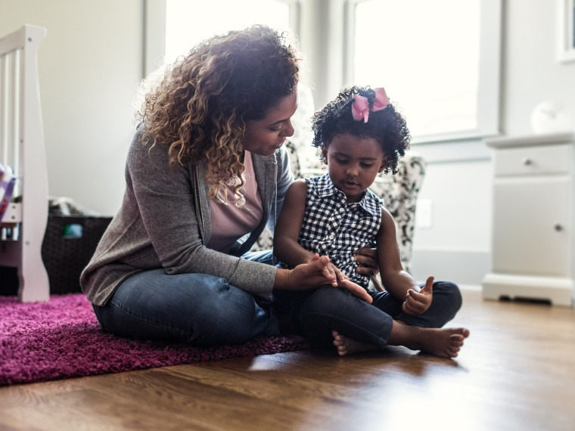

Professor Vivian Hill, of the Division of Educational and Child Psychology, says:

“Our children are constantly absorbing things they read, see and hear and it’s completely natural for them to be picking up on the situation in Ukraine and feeling anxious and also asking questions about what is going on.

“Children and young people have experienced an incredibly difficult two years due to the pandemic, and now they are faced with an even more uncertain world with the threat of conflict and war. It is important that we don’t avoid talking to our children about what is going on, but you might want to try to moderate their exposure to constant rolling news and updates.”

* **Give them the basics and don’t avoid the conversation** – Listen to their worries and provide honest answers to their questions about what is going on, don’t overcomplicate responses and try to give details at an age-appropriate level.  Don’t avoid answering their questions about the situation as this could promote more anxiety but keep to basic facts.
* **Ensure they feel supported and safe**– It’s important to help children/young people understand the level of threat to them and their friends and family. Explain this is happening in Ukraine, a different country and show this if necessary, using a globe or map.
* **Manage your own feelings** - Try to deal with your own feelings of stress and distress and those of staff in a way that it is managed as children/young people will be sensitive to your reactions.
* **Explain to children/young people that bad things can happen in the world but there is always some way we can help** - Plan together how you might deal with this situation through fundraising or other actions to support the Ukrainian community.
* **Avoid exposure to a constant stream of news** – Be mindful of the impact of the radio or TV and internet, as children/young people will be absorbing news without us realising it. Try to build in ‘breaks’ from the news, for example, if parents are picking up children up from school, advise they turn off the radio or make sure it isn’t on a news station to provide a break from the constant exposure to worrying rolling news cycles.
* **Watch where they are getting their news** – We know that fake news is an issue, particularly on social media sites so be mindful of what children/young people are absorbing and where they are getting it. Ensure they understand that not everything they see on social media sites is true, and they know what reliable sources of news they can access.
* **Seek advice and support if you are concerned about particular children** – Wider school staff and educational psychologists can offer specific advice and support if you feel that any child/young person is becoming overly anxious and distressed. Providing support and reassurance and diverting their thoughts through engagement in pleasurable activities can help. Any particular groups of students could also be supported via additional training from the EP Service or individual support from school link EPs. Any particular needs, please contact the service via: [educationalpsychologyservice@hillingdon.gov.uk](mailto:educationalpsychologyservice@hillingdon.gov.uk)

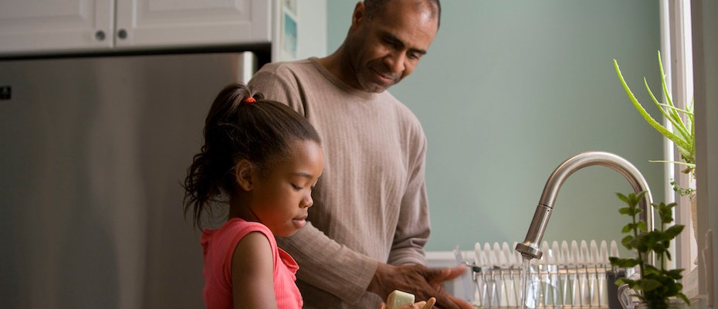

Talking to children and young people about war in Ukraine

1 March 2022 by [John McMullen](https://edpsy.org.uk/author/john-mcmullen/) and [Dan O'Hare](https://edpsy.org.uk/author/dan-ohare/)

Tagged: [anxiety](https://edpsy.org.uk/tag/anxiety/), [children and young people](https://edpsy.org.uk/tag/children-and-young-people/), [conflict](https://edpsy.org.uk/tag/conflict/), [Russia](https://edpsy.org.uk/tag/russia/), [Ukraine](https://edpsy.org.uk/tag/ukraine/), [war](https://edpsy.org.uk/tag/war/), [wellbeing](https://edpsy.org.uk/tag/wellbeing/)

*‘Children are both our reason to eliminate the worst aspects of armed conflict and our best hope of succeeding in that charge’*

## (Graça Machel)

The news is full of violent images, threats and foreboding. As parents, carers and educators our first thoughts are surely with the children and young people of Ukraine. Then they perhaps turn to the children in our own lives.

As much as we want to protect them from the news, to prolong the innocence and optimism of youth, there’s no bubble that can withstand the 24-hour newsreels,

social media notifications and playground chatter. Seeing posts about‘World

W[ar 3](https://www.google.com/intl/en/policies/privacy/)’,

talk of ‘planes’, ‘tanks’ and ‘bombs’ can cause anxiety at all ages. Even younger children, like little sponges, will absorb the mood of the room and the adult- whispered conversations.

Below we suggest some ways to support children and young people when having conversations about the current conflict and war.

# Take care of yourself

Perhaps you’ve shared the emotional experiences we had when news broke about the Russian invasion of Ukraine. Shock, despair, anxiety, uncertainty. These are big emotions for anyone to feel and as adults we often have increased access to rolling news bulletins, which can only magnify some of those feelings.

Spending some time getting to grips with your own feelings and emotional reactions can be an important step towards being able to effectively support the children and young people in your life.

Perhaps you need some quiet time, or to talk with friends or other important people in your life. It can be easy to get lost in the 24-hour news cycle, or news via Twitter, so trying to keep routines that are meaningful to you can be a boost e.g., that morning walk, or eleven am coffee.

# Listen to them

We can’t control everything children hear, and in the absence of the truth they will piece snippets together and create their own narrative. Open conversations will help you to deal with the exaggerations and hysteria that can develop on social media and WhatsApp groups.

Ask what they have heard and how they are feeling and listen to their responses. Validate their feelings. None of us like to be told to calm down or to stop worrying. The feelings are real and being allowed to express them helps us feel understood. Provide a safe space for children to ask questions and share fears.

Active listening involves giving children our full attention, repeating back what they have said to ensure we understand their point of view. How we respond will obviously depend on their age and emotional maturity. Be honest but reassuring at the appropriate level. Younger kids require safety messages, while older children and adolescents tend to need facts and context.

# Help them feel safe

Children need to see the world as safe and predictable. Experiences of trauma, or even images of trauma, can make the world feel an uncontrollable and unpredictable place. Look out for signs of fear or worry that they may not be willing or able to express. For example:

being more clingy than usual wanting more hugs and kisses becoming withdrawn

not sleeping or eating as well

becoming angry, irritable, tense or fidgety complaining of tummy pain.

We can’t (and shouldn’t) hide what is happening in the world, but we can limit the exposure by monitoring internet usage (depending on age) and not having constant news in the background on tv and radio. It might help to show a map of the world to demonstrate how far away the fighting is.

Bruce Perry [states that,](https://www.goodreads.com/book/show/129909.The_Boy_Who_Was_Raised_as_a_Dog) because us humans are inescapably social beings, the worst catastrophes that we can experience are those that involve relational loss. Therefore, recovery must involve re-establishing human connections. Perry suggests that the most important healing experiences often occur outside therapy and inside homes, communities and schools.

You may be supporting children who have direct experience of war and have had to [leave their home countries as a result. Much work supporting schools with refugee pupils has involved reassuring and affirming what they are already doing. School](https://www.stran.ac.uk/wp-content/uploads/2021/05/School-Based-Support-for-Syrian-Refugee-Pupils-in-NI-McMullen-et-al-2021.pdf) provides a secure environment with a predictable routine, clear expectations and [consistent rules. Refugee children and young people who participated in a study in Ireland described education as the most important factor in enabling ongoing ac](https://www.tandfonline.com/doi/abs/10.1080/21931674.2015.1074430)

[ce](https://www.tandfonline.com/doi/abs/10.1080/21931674.2015.1074430)ss

to social support and enhancing resilience. They described school-related

opportunities to develop social networks, create a sense of belonging, access information, and have recreational outlets.

# Look out for those who might be more vulnerable

Refugee and asylum-seeking pupils may have experienced trauma. This can increase the risk of psychological distress and potential social, emotional, behavioural and learning difficulties. Trauma experiences increase *the risk* of psychological distress and potential social, emotional, behavioural and learning difficulties. However, it is important to emphasise that not all refugee pupils will present with traumatic distress as a result of their experiences. Many display resilience, resourcefulness and high functioning despite the adversities they have encountered.

It is often [the post-migration factors](https://bmcmedicine.biomedcentral.com/articles/10.1186/s12916-018-1155-y), related to family, peer, community, school and service provision, that can either mitigate or exacerbate mental health difficulties.

Signs of trauma to look out for include:

flashbacks nightmares re-enactment

hypervigilance separation anxiety avoidance withdrawal aggressive behaviour lack of emotion developmental delay.

It is important to treat refugee pupils as individuals and not as a homogenous group. Often, they told us that they just wanted to blend in and not be seen as any different. This may sound obvious but here are the words of one pupil in [our research](https://www.tandfonline.com/doi/abs/10.1080/01629778.2020.1763095?journalCode=rebd20):

## …we had to do a poster about refugees. And in my last year [teacher] asked me to go to their classroom and talk more about Syria and the refugees and things. I found it kind of hard to talk at the back, old, harmful memories. And like I actually don’t want to talk about it

We might also need to listen out for how children might understand or talk about the different people involved in the conflict. It is easy in discussions about war and conflict to draw on notions of the ‘good’ or ‘bad’ side, and sometimes these ideas can be generalised to everyday life. Children, young people and families from Russia might be particularly vulnerable right now, as might children who speak Russian i.e., those from Estonia, Latvia, Belarus, Kazakhstan, Moldova and Georgia.

# Agency, play and positivity

We want to foster compassion and empathy. Helplessness and apathy are the real enemy. We all feel better when we can do something, so supporting action and agency in children is important also. You might then want to engage them in a discussion about how they could be involved in building a better, safer, kinder world. This might involve befriending the child in their class who doesn’t speak English yet; perhaps donating to a charity or bringing them to an anti-war protest.

Play is [fundamental for wellbeing and holistic development](https://www.csap.cam.ac.uk/media/uploads/files/1/david-whitebread---importance-of-play-report.pdf) (cognitive, social, emotional and physical). Children may re-enact or try to make sense of what they see on the news through their play, or perhaps through their drawing. We should encourage this where appropriate. These forms of storytelling can help them process without the need for words, with the added value of helping us to see where they are at.

Finally, we suggest trying to bring some positive perspective. We could talk about stories of reconciliation from Northern Ireland or South Africa or consider people who have demonstrated great acts of heroism or kindness during conflict. We might discuss times when our children themselves have overcome worry or fear in their own lives. In the words of Howard Zinn:

*‘If we see only the worst, it destroys our capacity to do something. If we remember those times and places – and there are so many – where people have behaved magnificently, this gives us the energy to act, and at least the possibility of sending this spinning top of a world in a different direction.’*

[edpsy.org.uk](https://edpsy.org.uk/)

# About John McMullen

John is an Educational Psychologist and a tutor on the Doctorate in Educational, Child and Adolescent Psychology at Queens University, Belfast. His research has involved developing, delivering, and evaluating interventions for war-affected children in Uganda and the DRC, as well as supporting refugee pupils in schools in N. Ireland.

View all posts by [John McMullen](https://edpsy.org.uk/author/john-mcmullen/)

# About Dan O'Hare

Dan is an educational psychologist and founder of edpsy.org.uk. He has a passion for the power of educational psychology and connecting EPs with each other